FOR IMMEDIATE RELEASE
Contact: Donna Wiedemeier, email: show@newenglandmeowoutfit.org, telephone: 856-384-2763
Website URL] https://NewEnglandMEOWoutfit.org
Purr-fect Family Fun: New England Meow Outfit Announces Annual Cat Show in Seekonk, MA This August
SEEKONK, MA — [July 20, 2026] — Feline enthusiasts, families, and pet lovers are invited to a weekend of whiskers and wonder as the New England Meow Outfit (NEMO) hosts its annual Cat Show on Saturday, August 22, and Sunday, August 23, 2026.
The two-day event will take place at the Ramada Inn, located at 213 Taunton Ave., Seekonk, MA, running from 9:30 AM to 4:00 PM daily.
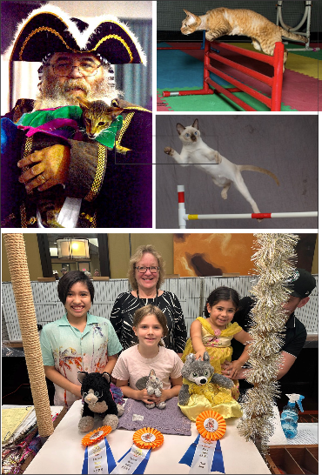
The show features a spectacular variety of cats competing for top honors, alongside unique public and exhibitor events designed to entertain visitors of all ages. Highlights of the weekend include:
- Agility Ring: Watch in amazement as highly athletic, exhibitor-entered felines navigate obstacle courses with speed and precision.
- Cat-and-Owner Costume Contest: A fan-favorite spectacle featuring creative, matching ensembles worn by exhibitors and their competitive cats.
- Kids Stuffed Animal Contest: A special, interactive event held both Saturday and Sunday, allowing younger feline fans to bring their own favorite plush toys to join in on the judging fun.
Our annual show is a fantastic opportunity for New England pet lovers to experience the incredible world of pedigreed and household pet cats. Whether you are a lifelong cat owner or just looking for a unique, family-friendly weekend activity, there is something truly special for everyone at NEMO."
Important Attendance Information
To ensure the safety and well-being of all competing animals, only exhibitor-entered cats are permitted inside the show hall. Guests are kindly asked to leave their personal pets comfortable at home.
Ticket & Admission Details
Admission tickets are available at the door, but advance online purchase is highly recommended to simplify entry to the show hall.
- Adults: $12
- Children (under 12): $10
- Children (under 5): FREE
- Household Packages: Multi-ticket discount packages are available for families.
Tickets can be purchased online by visiting the New England Meow Outfit Tickets Page and clicking the ticket icon.
For more information, schedule details, and to purchase tickets, please visit the official organization website at NewEnglandMEOWoutfit.org.
About New England Meow Outfit (NEMO)
The New England Meow Outfit is a Cat Fanciers’ Association licensed organization dedicated to celebrating the beauty, diversity, and welfare of cats. Through educational events, feline exhibitions, and community outreach, NEMO strives to promote responsible pet ownership while providing a welcoming platform for cat fanciers to showcase their exceptional feline companions.

