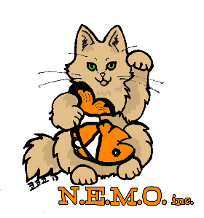
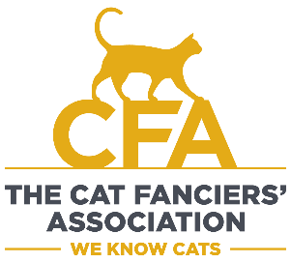
New England Meow Outfit
Cat Show
August 22 & 23, 2026
The Ramada Inn, 213 Taunton Ave., Seekonk, MA
9:30am to 5:00pm

9:30am – 4:00pm

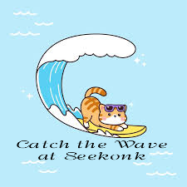
Special Events
(Saturday & Sunday)
Kids Stuffed Animal Contest
Exhibitors only, lots of fun to watch
Cat-and-Owner Costume Contest
Agility Ring
Raffle Table – All kinds of cool items

Website: https://NewEnglandMEOWoutfit.org
Important: Only exhibitor entered cats may be present in the show hall.
Admission: adults $12, children under 12 $10, children under 5 FREE! Household ticket packages available. Advance tickets recommended! Tickets available online: https://newenglandmeowoutfit.org/index.php/shows-events/visit-our-show (click the ticket)
