AGILITY RETURNING TO THE
N.E.M.O. CAT SHOW
A U G U S T 8/22 & 8/23/26

BE SURE TO MARK YOUR CALENDAR
SEEKONK MA
https://newenglandmeowoutfit.org/index.php/shows-events/special-show-events
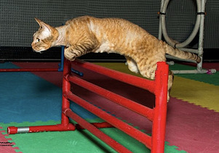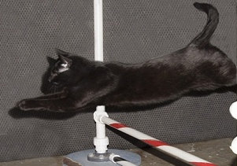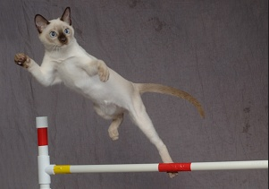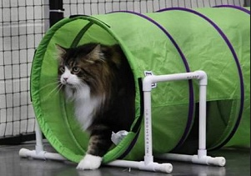

AGILITY RETURNING TO THE
N.E.M.O. CAT SHOW
A U G U S T 8/22 & 8/23/26

BE SURE TO MARK YOUR CALENDAR
SEEKONK MA
https://newenglandmeowoutfit.org/index.php/shows-events/special-show-events

