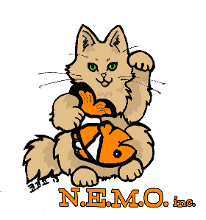
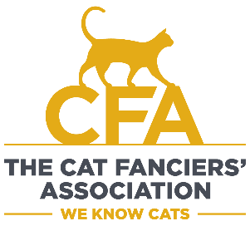
CFA -- CAT SHOW -- MetroWest Boston
New England Meow Outfit, Inc. (NEMO)
August 24th and August 25th 2024
The Verve Hotel, Natick MA

Special events each day along with the Cat Show:
Saturday: Children’s Stuffed Animal Contest (entries are limited so sign up early !)
Sunday: Cat & Owner Costume Contest - Master of Ceremonies Russell Webb CFA Vice President AND
Special Guest Judge, Ron Bell

Location: The VERVE Hotel Boston, 1360 Worcester Street, Natick, Massachusetts, FREE PARKING !
Contact: Donna Wiedemeier, (856)384-2763, adm192007@yahoo.com (Show Manager & Show Chairperson)
Breeders will be on hand to meet spectators and help them learn about the different breeds. Over 100 cats in over 30 pedigree breeds along with household pets make this a cat lovers dream event. Eight professional judges, affiliated with the Cat Fanciers’ Association (the world’s oldest and largest registry of pedigreed cats), will present and evaluate the cats for awards. Pedigreed cats will be judged based on their breed standard, which details the “perfect” example of each breed – for example, head shape, body length, coat quality, and color. Household pets are judged on an individual level – their looks, personality, coat condition, and grooming.
Vendors of cat-related articles will also be on deck for your shopping pleasure, and a raffle will offer visitors a chance to win everything from cat trees to jewelry to wine.
Saturday’s special event is the Stuffed Animal Contest with prizes. Sunday is the wonderful Cat and Owner Costume Contest but requires the cat be entered in the cat show in order to compete. The Costume Contest judge, returning from last year, is Ron Bell of WGBH’s Boston Black News and co-host of the Morning Crew radio show on WBPG-LP 102.9 FM.
Area cat lovers are welcome to enter their own cats (by August 21) so they can participate in the show, too. Kittens and Household Pets can be entered without a CFA registration number, but all others must obtain a number from CFA. (More info at https://cfa.org/ new-england-meow-outfit-aug23/ )
Spectators are welcome throughout the event, which runs from 9:30am - 4pm each day.
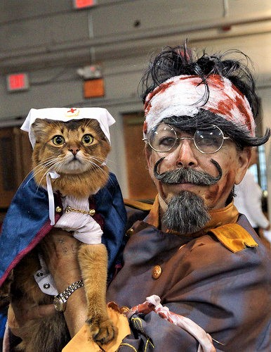
Admission is $12 for adults, $10 for children under 12, children under 5 are FREE !! Household ticket packages available. Advance tickets are recommended due to limited capacity ! Tickets available via: https://nemocatshow.ticketleap.com
