New England Meow Outfit, Inc. 2024 Sponsorship Opportunities
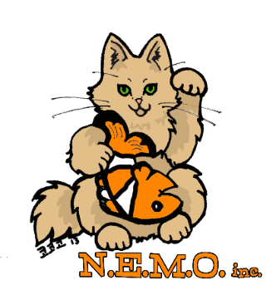
New England Meow Outfit, Inc., commonly known as N.E.M.O., is producing its 11th annual cat show and its third show in Boston’s Metro West area. The show will be held Saturday and Sunday, August 24 and 25, at The Verve Hotel Boston-Natick, 1360 Worcester Street, Natick and will be open to the public both days. There will be four judging rings with a different judge each day. We will be advertising in the greater Boston area and are hoping for a large influx of spectators. We had nearly 4,000 attendees in this location last year.
NEMO is a cat club affiliated with the Cat Fanciers’ Association, the world’s oldest and largest registry of pedigreed and companion cats. We are dedicated to educating the public about the different breeds of pedigreed cats as well as about all cats in general.
This year, we are offering three levels of sponsorship to businesses, catteries, and individuals. Create your own signage and send to us, or let our designer create materials to your specifications!
GOLD SPONSORSHIP $325* This premium sponsorship includes:
- Full color 24 x 18” sign with your custom message as well as your company name imprinted on the rosettes, for one double ring.
- Full page ad in the show’s catalogue, which will be distributed to all exhibitors. We expect 150-165 exhibitors.
- You are welcome to display brochures or business cards at our entry gate area.
SILVER SPONSORSHIP $250* This value-priced sponsorship is ideal for small businesses. It includes:
- Half-page ad in the show’s catalogue as well as your company name imprinted on the rosettes.
- You are welcome to display brochures or business cards at our entry gate area.

BRONZE SPONSORSHIP $125* Ideal for individuals, this sponsorship includes:
- Full page ad in the catalog.
- You are welcome to display brochures or business cards at our entry gate area.

Whatever level your business chooses, you will also receive a writeup on our Facebook page, which has over 1000 followers. In addition to being a sponsor, we also accept raffle donations for our huge raffle. Samples of your product are also accepted as handouts to our exhibitors. This is a great way to promote your product. All donations will be acknowledged in our catalog.

*Exhibitors please note: if your cat is competing in the show, your cattery sponsoring sign cannot be placed in a judging ring. We will display signs for catteries competing at the show on our raffle table or another prominent location. You may want to consider a memorial sponsorship for a Rainbow Bridge cat, as that can be placed in a ring.
If you are interested in becoming a sponsor, please contact Donna Wiedemeier, show manager, at adm192007@yahoo.com, 856-384-2763
or Gretchen Carr, assistant show manager, at carrgvp@gmail.com, 508-380-5409

ALL CONTENT FOR SIGNAGE MUST BE RECEIVED BY JULY 13 TO ALLOW ADEQUATE DESIGN/PRINTING TIME!

